Course Calendar
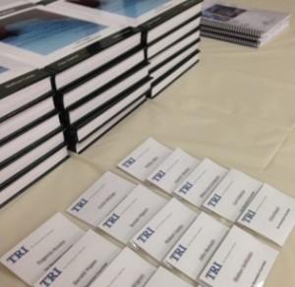Below is a list of courses we offer spanning the following months. For a comprehensive list of courses offered contact us.
We offer instruction for CPE/MCLE* credit for our live courses and webcasts as prescribed by the National Association of State Boards of Accountancy (NASBA) in all 50 States.
Note that both live and online courses fill up quickly. Be sure to reserve your spot if you are interested in taking a particular course. Be sure to check back regularly as this page is constantly being updated.

July 17, 2015 (8am PST) | Tax Resolution Essentials 200A – Intermediate Tax Resolution
CPE/MCLE Credits: 8 hours
This course offers comprehensive full-day instruction both live as well as simultaneously webcast nationwide. Click below for more details and to sign up.
More Information

October 23, 2015 (10am PST) | Tax Resolution Essentials 100A – Introduction to Tax Resolution
CPE/MCLE Credits: 2 hours
This course is a must for anyone representing taxpayers. Even though the class is introductory, you will leave having several valuable tools to help your clients “right out of the gate”.
More Information

October 30, 2015 (10am PST) | Tax Resolution Essentials 305A – IRS Audits…Is it Art or Science? NEW!
CPE/MCLE Credits: 2 hours
This isn’t your father’s audit course. Learn things no one thinks of when they represent their clients in an audit. How can you afford not to take this course?
More Information

November 6, 2015 (10am PST) | Tax Resolution Essentials 120A – Offers in Compromise and Appeals NEW!
CPE/MCLE Credits: 2 hours
If you practice in this field or have any intentions of submitting an Offer in Compromise or filing an appeal, you want to take this course. This is a great follow up to Tax Resolution Essentials 100A.
More Information

November 13, 2015 (8am PST) | Tax Resolution Essentials 200A – Intermediate Tax Resolution
CPE/MCLE Credits: 8 hours
This course offers comprehensive full-day instruction both live as well as simultaneously webcast nationwide. Click below for more details and to sign up.
More Information

