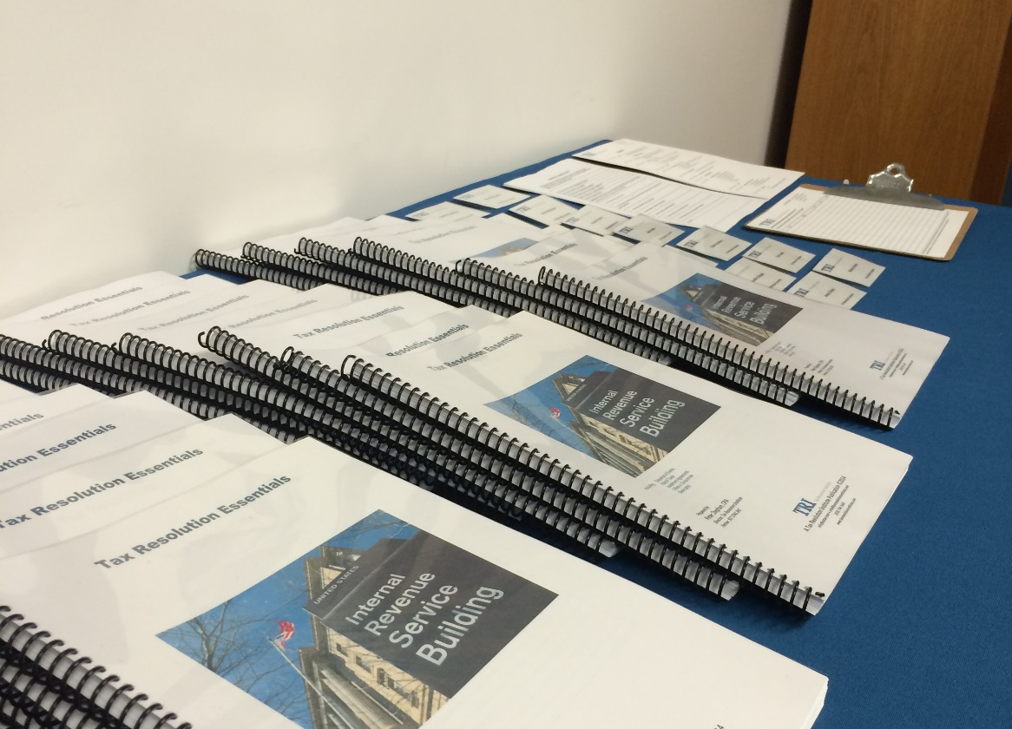
  October 29, 2019
November Edition |  | In This Issue

This newsletter is created primarily by using text columns, so that text automatically wraps from one column to the next. Find the Columns feature on the Page Layout tab, in the Page Setup group. Get tips for setting up and using text columns later in this template

Adding your own content
The placeholder text for several articles in this template provides tips on how to customize this newsletter for your needs.
To replace any placeholder text with your own, just select it and start typing. Note that if the placeholder text you replace is long, such as for this article, it might look like the page layout is skewed when you do this but it is not. The content that sits lower on the page only moves up because less content is present when you begin to replace your own text. As you type to add your text, content will move back into position automatically.

Placeholders that remain when you add text
The title and subtitle placeholders don’t disappear when you add your own text. They will look like regular text when printed but you can see the blue outline and title of the placeholder when you click in it.
The reason these placeholders remain is that they are linked to other placeholders that use the same text. So, when you replace the title or subtitle placeholder text with your own, it automatically populates the corresponding placeholders in the headers and on the back page mailer.

Replacing pictures
To replace a picture in this template with your own, select it and then, on the Picture Tools Format tab, in the Adjust group, click Change Picture. (Or right-click a photo to access the Change Picture command.)
The pictures that you see in sidebars, such as In This Issue at right, are formatted as In Line With Text so that they sit right in a paragraph mark and can be formatted as easily as text. The custom paragraph style named Sidebar photo applies indent formatting that helps align the photos perfectly with the other sidebar content.
Pictures that wrap around some text in articles throughout the newsletter use text settings and positioning. Get help for working with text wrap around pictures later in this template.


How to Use This Template
by [Article Author]

Peter’s Tip of the Month
A column break is inserted before and after each column that acts as a sidebar. To insert a column break, press Ctrl+Shift+Enter. Or, on the Page Layout tab, in the Page Setup group, click Breaks, and then click Column.

Upcoming Events
Seminars

Webinars

Be sure to visit us at www.taxresolutioninstitute.org

