

Speaker Name

Certified Public Accountant

Mr. Stephan is qualified by the State Bar of California, California Board of Accountancy and the Internal Revenue Service to provide continuing professional education to Attorneys, Certified Public Accountants and Enrolled Agents in the area of tax resolution.

Call us today to find out how you can reach new heights.

(800) 555-0100

Solve these problems and expand your practice at the same time!

Tax Resolution also known as Tax Controversy is the fastest growing area in the accounting profession due to today’s financial climate. Do not miss the opportunity to help your clients and make money in the process. This work is relatively easy if you know how to do it.

Become an expert in:

- Installment Agreements
- Offers in Compromise
- Discharging taxes in Bankruptcy
- And much more….

You are cordially invited to attend our upcoming full-day seminar:

(8 Hours of CPE Credit)
(Lunch Provided)

Location:
750 3rd Avenue, 11th Floor
New York, NY 10017

Only $349.00*
(If you sign up before December 31,
$399.00 at the door)

Attorneys, CPAs and EAs

IS YOUR FIRM
READY TO REACH
NEW HEIGHTS?

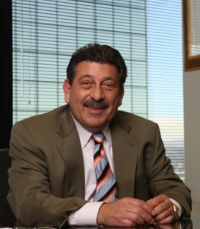


COMPANY WEBSITE

