
Design Your Professional Website

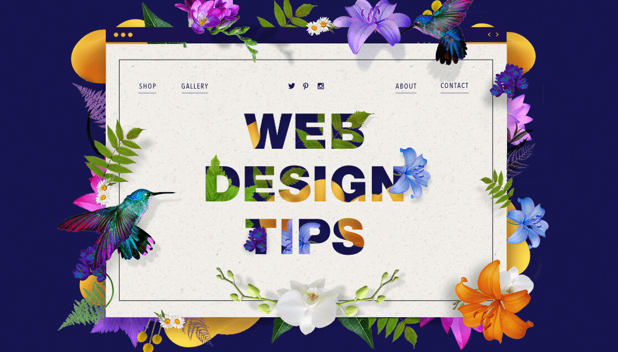

“Beauty is in the eye of the mouse-holder.”

A website cannot succeed solely through compelling design or thought-provoking content. It needs to have a style that feeds into your website’s user experience and functionality while being easy to understand at first glance.

First, Pick a Website Builder: Wix.com, Wordpress.com, and SquaresSpace.com

This ultimate guide will cover a basic step-by-step process of creating your own professional website as well as a list of tips and tricks to remember while working with each of these expert builders.

Wordpress.com

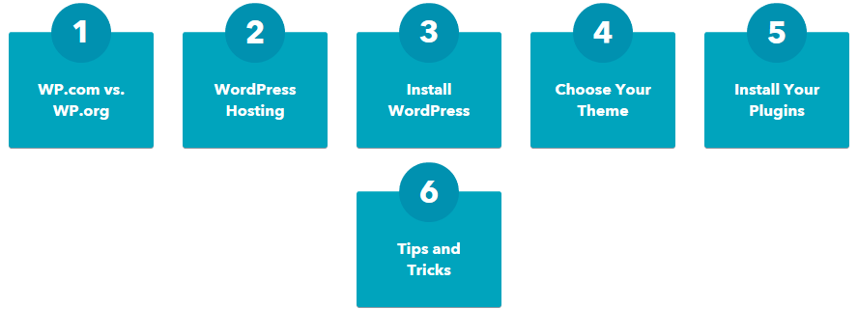

How to build a WordPress Website:

- Select a WordPress plan: Personal, Premium, Business, and eCommerce
- Set up your domain name and hosting provider: There are hundreds of third-party hosting services, such as GoDaddy or Bluehost, that provide you with the ability to create custom domain names.
- Install WordPress
- Choose your theme- You can customize your website using WordPress’ themes and templates, which contain a multitude of layouts, formatting styles, colors, fonts, and other visual options.
- Add posts and pages to your website- Once you discover the perfect theme, simply “Install” it to begin customizing it and adding your own content, posts, and pages.
- Customize your website
- Install your plugins
- Optimize your website to increase page speed
- Get inspiration from WordPress website examples



Wix.com

- Set your goal- Before starting, you need to be crystal-clear about what you want to achieve. A website can take many different forms, including:

- An online store to sell your products to the world (wide web).
- A portfolio to showcase your art.
- A landing page to promote a marketing campaign.
- A resume website to convince recruiters.
- A blog to share your knowledge.
- An event website for your weddings, parties and company events.
- Choose your website builder
- Define your layout
- Claim your domain name
- Gather your content
- Add the right pages
- Put usability first
- Do your SEO
- Pick the professional tools you need
- Make it accessible to everyone
- Engage with your visitors
- Optimize for mobile
- Call a friend
- Publish - and get back to it

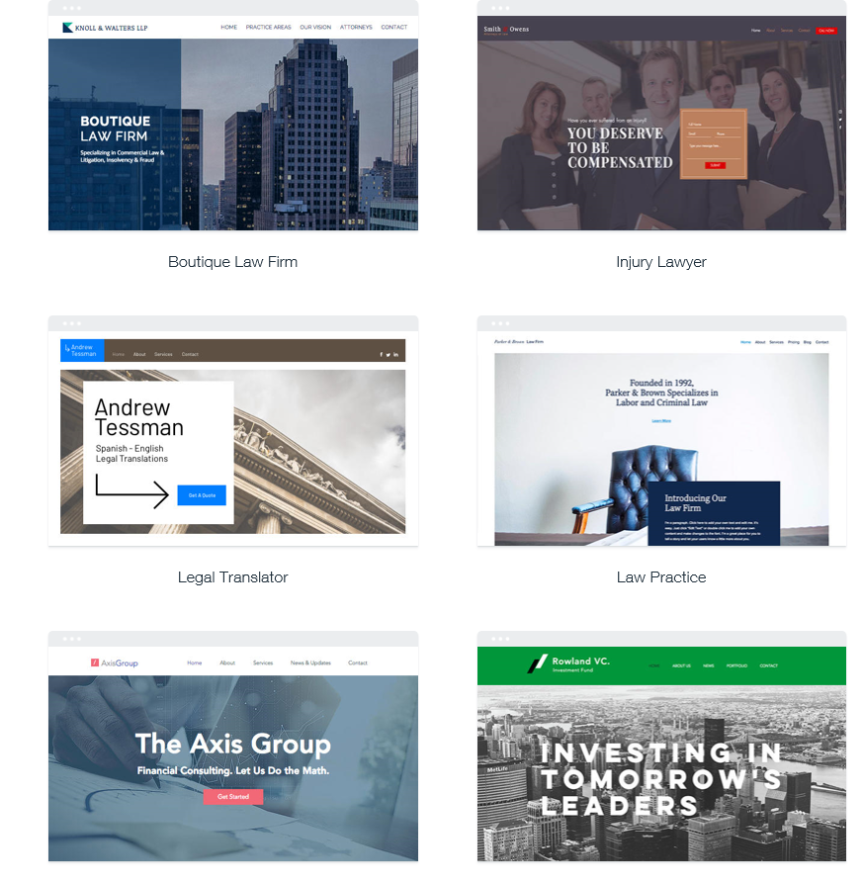

Design Tips to Have Your Website Looking Professional:

- Keep your homepage minimalistic and free of clutter- We rarely read every word on a website. Instead, we quickly scan pages, picking out keywords and sentences.

- Design with visual hierarchy in mind- It remains the designer’s job to arrange the content in a clear manner. You only have a few seconds to grab someone’s attention and tell them what your site is about- establish a clear hierarchy to your information.

- Create easy to read website content- When your site’s readability is high, users will be able to efficiently scan your site and take in the information in the text without much effort.

- Ensure your site is easy to navigate- Link your logo to your homepage:

- Stay mobile friendly- We live in a mobile society, which makes it important to ask the question: What do my visitors see when they access my website on the go?

It’s important to guide your visitors through the buying journey using strategic call to actions. Here are a few different actions an audience can get called to carry out:

- Sign up.
In this type of CTA, the audience might be invited to sign up for a free trial, an online course, a future event, or even a software product. It all depends on the CTAs context on an ad or website.
- Subscribe.
This CTA doesn't commit a person to a purchase. Rather, it invites them to receive updates from the company. "Subscribe" CTAs are common to company blogs, for which the business wants to develop a readership.
- Try for free.
Nearly every company website has a free trial offer today. Each of them are CTAs of this variety, and they allow people to demo a product before deciding if it's worth the cost to them.
- Get started.
This CTA can drive a variety of behaviors for a company, from a free trial to virtual reality experience.
- Learn more.
Sometimes, all you want is to give your potential customers a little more information, so they're prepared to buy something. That's what this CTA is for.
- Join us.
Do you manage an online community? Is your product built on collaboration between users? You might find yourself placing "join us" CTA somewhere on your website.

Website Feature Checklist- Non-negotiable standards to implement
1. Fast Loading -- No one wants to wait (and wait and wait) for your site to load. Design sites with prompt loading times for all users on all devices.
2. Mobile Ready -- Virtually everyone uses smart devices daily. Create an engaging, mobile-friendly design that your audience can access whenever they want.
3. Tracking Enabled -- Analytics matter - it’s the best way to determine that your website is doing its job. Key indicators- traffic, goals, and conversions.
4. SEO Savvy -- Don’t underestimate the power of optimizing your site for both browsers and humans. For the search engines, always include all important on-page SEO tags and elements.
5. Enabled CMS -- Consistently publishing fresh, original content not only captivates your audience, it can deliver invaluable, long-term digital marketing momentum. Include a back-end Content Management System in the design so clients can post and edit content as needed.
6. Conversion Optimized -- Have a conversion-centric client? Implement tools for creating campaign landing pages into your design. These designated pages can keep your readers moving through your site and direct them to schedule an appointment, request a product demonstration, and even make a purchase.
7. Email Marketing -- A site’s email capture forms should sync with the client’s email marketing system for seamless access and connection.
8. Social Media -- Never miss an opportunity to leverage the power of social media. Integrate all relevant social media platforms within your design to broaden your reach, increase visibility, and traffic.
9. Strong Security -- Never compromise on-site security. Every design should include fundamental security and privacy protocols, such as basic security checks, to protect client and user data.

How to Write a Blog Post in Five Easy Steps
- Plan your blog post by choosing a topic, creating an outline, conducting research, and checking facts.
- Craft a headline that is both informative and will capture readers’ attentions.
- Write your post, either writing a draft in a single session or gradually word on parts of it.
- Use images to enhance your post, improve its flow, add humor, and explain complex topics.
- Edit your blog post. Make sure to avoid repetition, read your post aloud to check its flow, have someone else read it and provide feedback, keep sentences and paragraphs short, don’t be a perfectionist, don’t be afraid to cut out text or adapt your writing last minute.

