Social Media Marketing 101: The Ultimate Beginner’s Guide

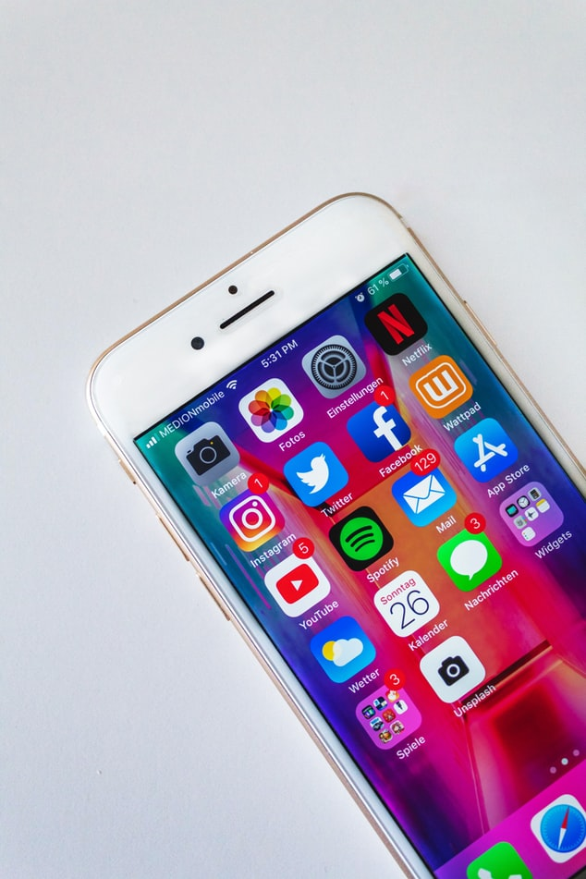

Organizations today must be willing to engage directly with customers through various social platforms if they want to grow.

A good social media strategy will not only influence customer buying decisions, but curate referrals as well as organic reviews.

To reach people on these platforms, your business needs to understand where your targeted customers like to engage and how to create a marketing campaign that will interest them.

I know you might be thinking, where do I begin?

With this Social Media Marketing 101 guide you will learn how to effectively build your presence on these sites, so that these elements start working in your favor.

What Can Social Media Marketing Help Me Accomplish?

With authenticity and transparency, social media can help you accomplish the following goals:

- Community building and relationship building, fueled by generating discussion- People don’t just want to see some ad copy—they want to feel like they’re getting to know you and your business, because social media is just that: social. If you’re able to put the connection building first, you’ll be off to a great start.

- Brand awareness & discovery (particularly if you’re using social ads)- Announce new products and business developments to your enthusiastic audience.

- Increase both registration and attendance by promoting events.

- Increasing site traffic as a result of referral clicks.

- Providing value to your audience and establishing your expertise in your field.

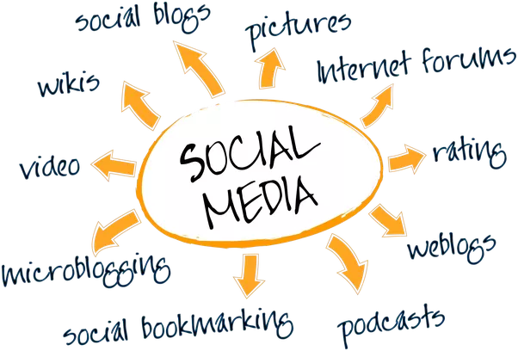

We have a powerful tool at our fingertips that can share pieces of content all over the world in seconds. Social media marketing will increase your brand’s awareness, customer loyalty, conversion, humanization, customer insights, customer service, inbound traffic, and need I say more?

Social Media Platforms to Consider

There are many different social media sites that you can join to promote your business. Here are the platforms that seem to generate more audience engagement than others.

Yelp- Consumers who use online review sites trust Yelp more than any other – making Yelp and Yelp ads more influential in final purchasing decisions when compared to other review and social media platforms.
- Know your audience to get new customers.
- Add & Claim your Yelp Business- first, you need to ensure your business is properly listed, set up, and optimized for success.
- Look at the competition before optimizing your profile.
- Encourage customers for yelp reviews- this is the lifeblood of yelp and local SEO (add keywords)
- Be active and engage
- Run yelp ads- They are flexible, budget controlled, can be customized, and provide display options.

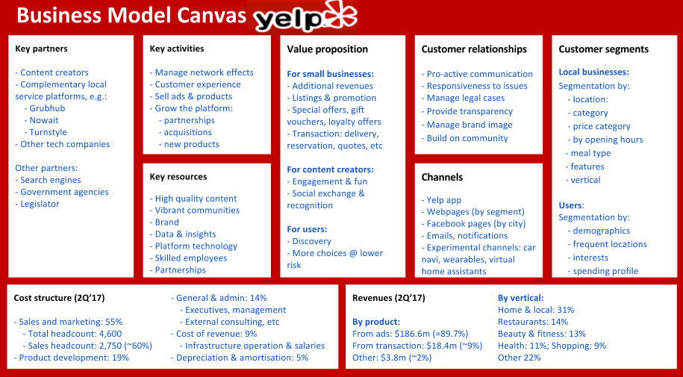

LinkedIn

Utilizing LinkedIn is a valuable resource and should be one of the first profiles you create if you’re in a B2B industry. Create profiles for both your personal page and your company.

It’s where professionals go to share industry news, and a slightly higher caliber of discussions.

To get the most out of LinkedIn, you should be posting content that both peers and potential customers would find valuable, actionable, and thought provoking. This is the content that’s shared most often, and what generates the most discussion, and discussion is always a good thing.

Tips for getting noticed on LinkedIn
- First build a strong business page to attract attention to your brand. Tailor your summary and services descriptions to your audience– busy professionals. Consider what you would say at a networking meeting.
- Use relevant keywords when you can to boost your chances of appearing in searches.
- Write material that will be helpful and engaging to this professional audience-all material written or posted closely aligned with the atmosphere of the platform. Helpful articles related to your business as well as more generalized pieces– such as work/life balance, leadership, or time management– will be appreciated.
- Post during peak usage times– about 7-8 am, 12 pm noon, and after work– about 5-6 pm. Post scheduling can help you ensure that your posts go live during these windows to maximize engagement.

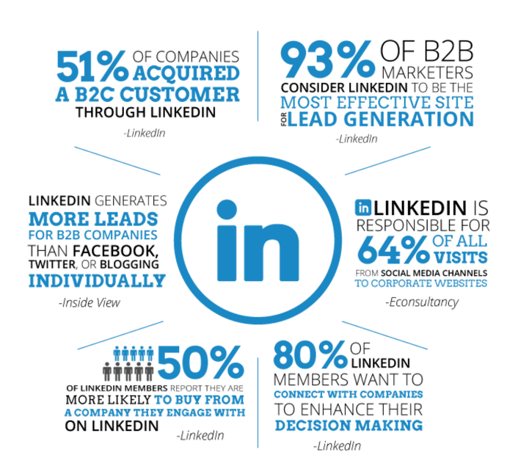
Your employees can also help represent you on LinkedIn, since your current place of employment and work history appear on your profile, encouraging employees to demonstrate expertise in the industry and engage on the platform can boost your own reputation.
Facebook- Customer can see your business hours and store location on a map, write reviews, and view all your latest content.

7- Step Facebook Marketing Strategy:

- Set Goals- What results are you looking to achieve from your Facebook marketing strategy? Are you trying to gain brand awareness, increase website traffic, gain leads? When setting goals, it’s a great idea to use the SMART strategy. That is, setting goals that are specific, measurable, attainable, relevant, and timely.

- Pinpoint your Target Audience- Facebook marketing is useless if you aren’t reaching the right people.

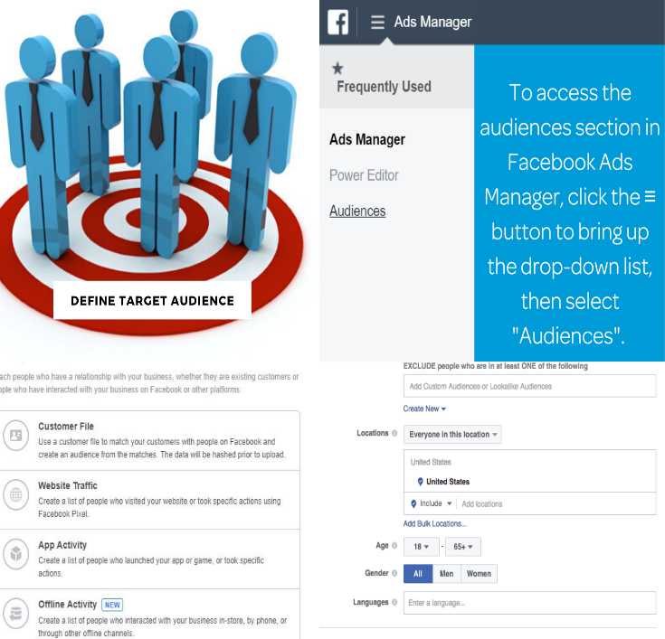

- Click on the “Audience” section

- Next, click the “create audience” and select “custom audience” on the dropdown list.

- Create a custom audience using a list of information on previous customers (names, #, email) or generate a “lookalike audience” (like current clients).
- A big pond doesn’t necessarily mean you’ll catch bigger fish. You can click “narrow audience” if you think it may be too big.

- Set your Budget- A typical Facebook marketing budget would include page like ads, conversion and/or lead generation ads, boosted posts, and content creation. The more money you put behind your page like ads, the more followers you can expect to receive. Conversion ads are the ads you will use to generate sales and lead ads are the ads you will use to generate leads who can be turned into customers.

- Plan Engaging Content- We recommend planning posts about a month in advance (plan for any upcoming holidays, events etc.) and maintain a regular posting schedule- five posts per week.
Remember these simple tips:
- Ensure you’re only publishing high-quality content. It’s a good idea to include an image- On average, Facebook posts with images receive more than twice the engagement those without images do.
- The written text included with your posts should be short, but not too short. A good rule to follow is including three sentences in your copy: one to grab attention, one to add value to your post, and finally a call to action.
- Diversify the types of posts you put out.

- Plan Equally Engaging Ads through Quality! – Create bright, clear images with faces in them and videos that convey meaning without the need for sound. When it comes to ad copy, your call to action will depend on your ad objective.

- Monitor Daily

- A/B Split Test - This is when you compare small variations of a strategy to figure out which aspects work the best. Simply click onto your Facebook page and click “Insights”. Facebook Ads Manager will provide you with statistics on cost per click, click-through rate, total ad reach, and more!

Now that you have a Strategy in place here are some Tips for Getting Noticed:

- Use the highest engagement periods. Users are most likely to be on Facebook from Thursday through Sunday, with the highest usage rates over the weekend. The most popular times appear to be around 9 am, 1 pm, and 3 pm. Posting in these windows can help increase engagement.

- Create a strong business page. Use keywords create a summary targeted towards the average browser and include the business’s contact information.

- Keep it active! Post interesting articles followers will like. Do not just post things you have written. They can be by other brands if you believe your readers will appreciate them. This platform allows you to build friendships, so imagine speaking with a friend as you write.

- Engage in conversations. Ask open-ended questions and answer any messages sent directly to you promptly. Let people know that you want to engage with them.

Twitter
Twitter will only be effective as a marketing tool, if the platform is used to generate discussion and conversate with other users.

- Pick the right handle (@”name”-short and sweet), professional profile photo, and header image.
- Create thought-provoking content, polls, and question-based posts that are designed to get more retweets and responses.

- Post during peak engagement periods: statistics show this occurs around lunch time, 3 pm, and between 5 and 6 pm- Tweeting a few times during each of these windows– rather than one post the way you would on Facebook or LinkedIn– will give you the best results.

- Occasionally reuse tweets, particularly those that have a high value for your organization. Retweet the tweets from others in your industry when you think they would benefit your audience will help you attract attention.

- Include people or businesses in your tweets when they are relevant by using the ‘@’ sign to signal them.

- Include the right #hashtags to make your posts more searchable and help people find your brand when you use a #hashtag about topics that interest them- use to a minimum.

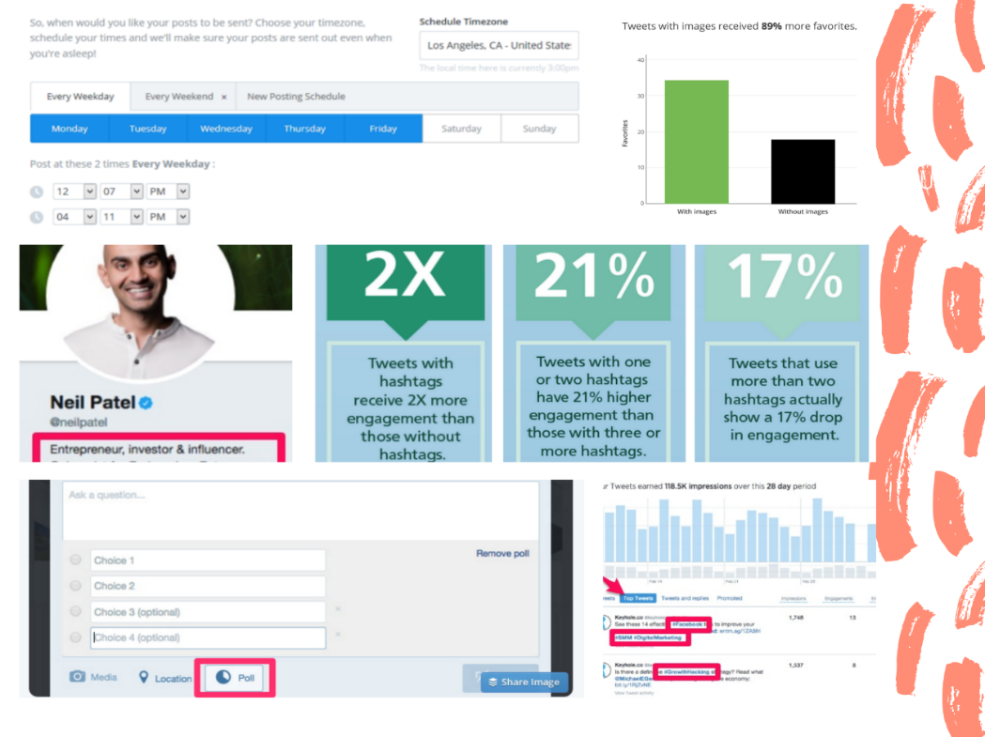
Be consistent in your Twitter engagement and creative in your posts. Include images, tweet content that you personally developed, and content created by others in your field.
Instagram
Instagram is a predominantly visual platform, with aesthetically stunning and interesting videos and pictures reigning supreme. Instagram also has some of the highest engagement rates out of all social platforms.

Tips for getting noticed on Instagram
For best success on Instagram, use all the features that are available to you:
- Create a business profile- (add a phone number, website link, etc. to your bio).
- Create Stories and newsfeed posts
- Heavy use of hashtags to generate discussion (aim for about 5-10 per post), encourage user-generated content and help attract new followers.
- Use your business profile ‘insights’ to post during the most engaged times for YOUR business- popular times for this platform are Mondays and Thursdays from 8-9 am and 5 pm.

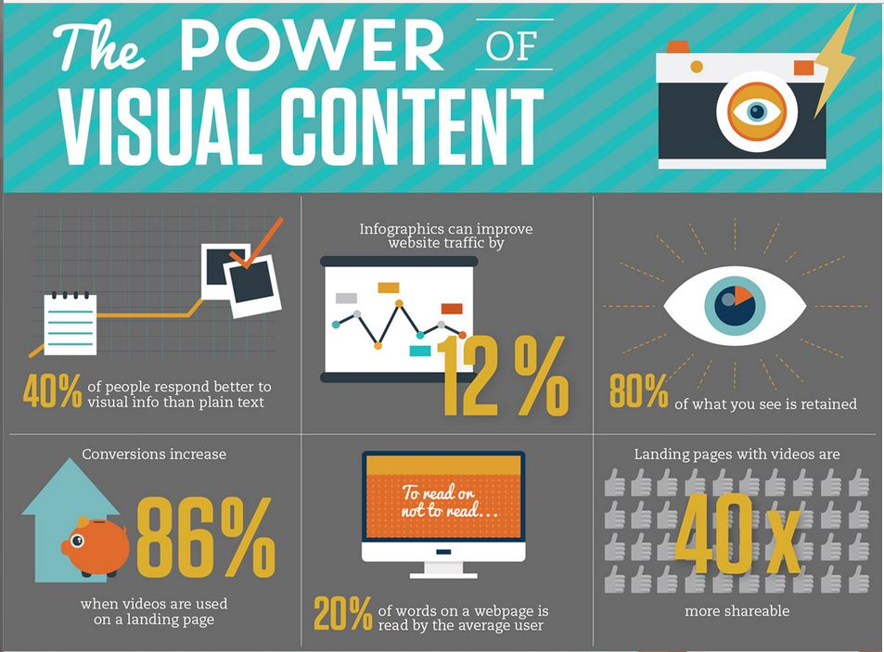

YouTube
YouTube is as old as Facebook and it’s the largest digital marketing (mixture of a content & social media marketing) platform around.

- Create channel name, icon, and strong description (for SEO/video rankings).

- Keywords are an exceptionally important part of YouTube marketing- Place them in your video’s title, description, category, and tags.

- Create video that provides value to your audience through tutorials, how-to demonstrations, Q&As and informational content that your audience is actively looking for. For example, TRI provides basic information on various elements in tax resolution and then we link this to our products/webinars/educational tools in the descriptions.

Tips for getting noticed on YouTube
To build viewers for your videos, you need to focus on building an entire quality channel. The number of followers you earn, the number of videos your audience watches, how much of the videos they watch, and the interactions sparked by the videos all factor in.
Remember to always send traffic back to your main site when possible, as that’s a crucial part of finding success on this platform
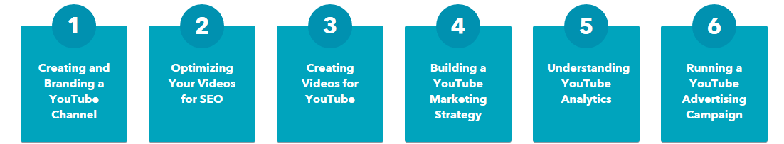

Conclusion
Social media marketing has an enormous and diverse audience, and it’s free and accessible. It’s an excellent opportunity to nurture relationships and build an online community, solidifying your place in your customers’ lives. Just remember that for social media to benefit your business, it must be carefully maintained and monitored. Start slow and small, and scale from there.

